**Quantum Computing with IBM- online cloud computer**

At IBM, people are conducting research to build a universal quantum computer. To accomplish it, they are opening the quantum computing capability on the cloud and making them available to anyone interesting in learning or experimenting with quantum information.

Classical computers gave us the internet, Smartphone and even send humans to the moon. But if we try to simulate a single molecule of caffeine to understand how it impacts on human brain, it’s impossible because there is too much information. Quantum computer is may be ideally suited to it.

IBM is making open source software developer tool

1. "qiskit"
2. IBM Q Experience

It is a free way to experiment.

Quantum computer can be used to encoding the information into quantum states and it may be used to make calculation which is quite impossible by employing classical computer today. We can use the quantum computer to finally understand how small molecules are able to change our brain chemistry and psychology.

IBM is already working on it and they have developed an open source platform called IBM Q Experience (<https://quantumexperience.ng.bluemix.net/qx/editor>) and Qiskit (<https://qiskit.org/>). They are cloud based platform which anyone can access from their classical computer by simply following the instruction given in their corresponding web space.

**Steps to start working on IBMQ:**

1. **IBM Q Experience**

**Step-1:** Open the URL given below

<https://quantumexperience.ng.bluemix.net/qx/editor>

It looks like this>>

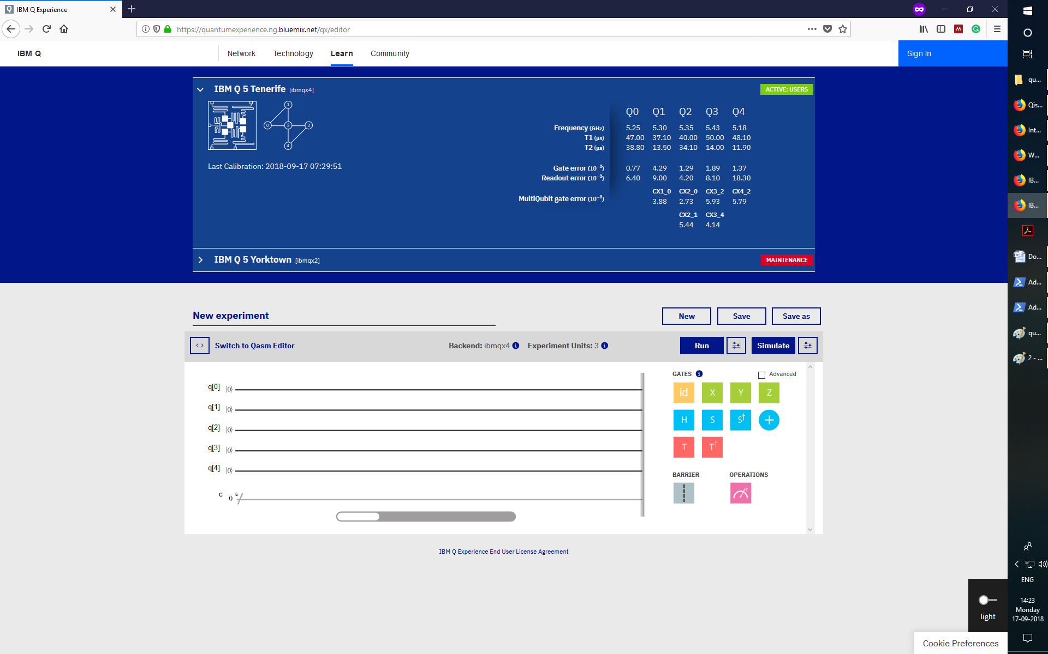

**Step-2:** Run an example program to understand how to use quantum computing algorithm in a very simple manner...

In this example, the Grover’s Algorithm has been used. Grover’s algorithm has highest capability to search the database. It provides required outcome by searching a huge amount of data in less amount of time.

To understand this, let’s consider a card game. Suppose there are four cards and among them only one queen. The task is to find queen among all face off cards.

This experiment can be performed and it is possible to get queen in one shot (or one attempt). The Arrangement of gates to compose this program is given below.

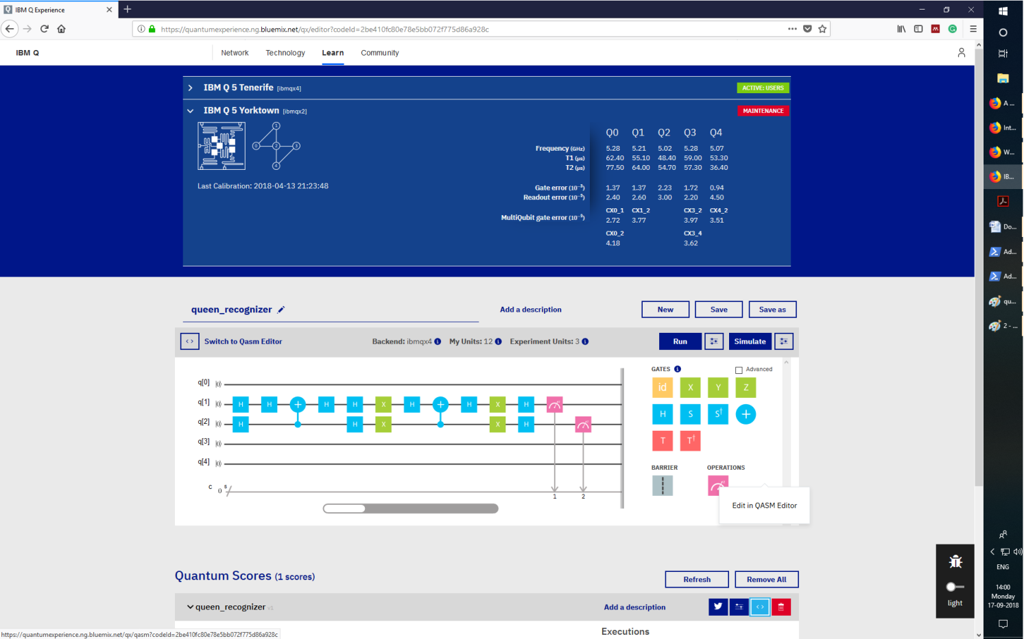

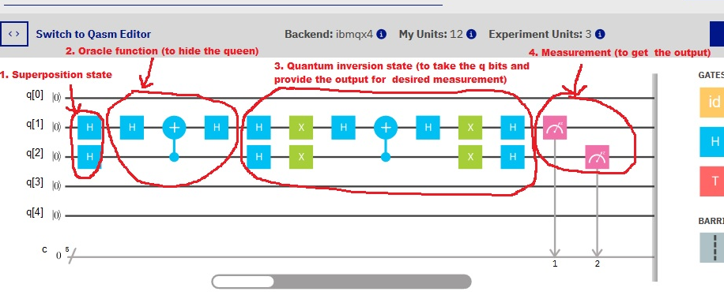

1. **Superposition state:**

This is the first part of the algorithm made by two Hadamard gate (H-Gate) which involves with Qbit-1 and Qbit-2 and it is responsible to make superposition of bits.

1. **Oracle Function:** The second part is called oracle function and this is to hiding the queen.
2. **Quantum inversion:** Third part is the sequence of gate which contains the major power of the algorithm. It takes the entangled space of Qbits and produces something that can be measured.
3. **Measurement:** It is used to take the output of the algorithm.

**Step-3:** Hit the **run** button, select the **one shot** option, select **new execution** and wait for the program to be execute.

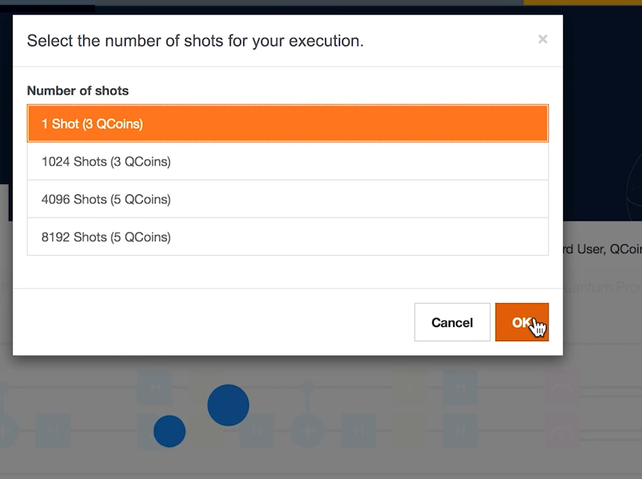

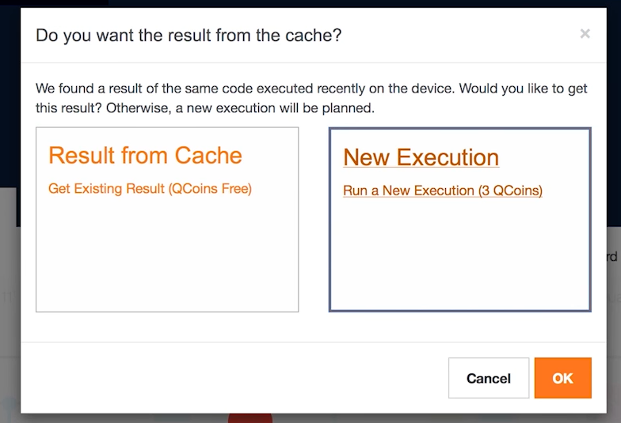

**Done your program has been now running on real quantum computer.**.. wait for the result.

**Results:**

After some time when execution done, click on my quantum score and check execution result.

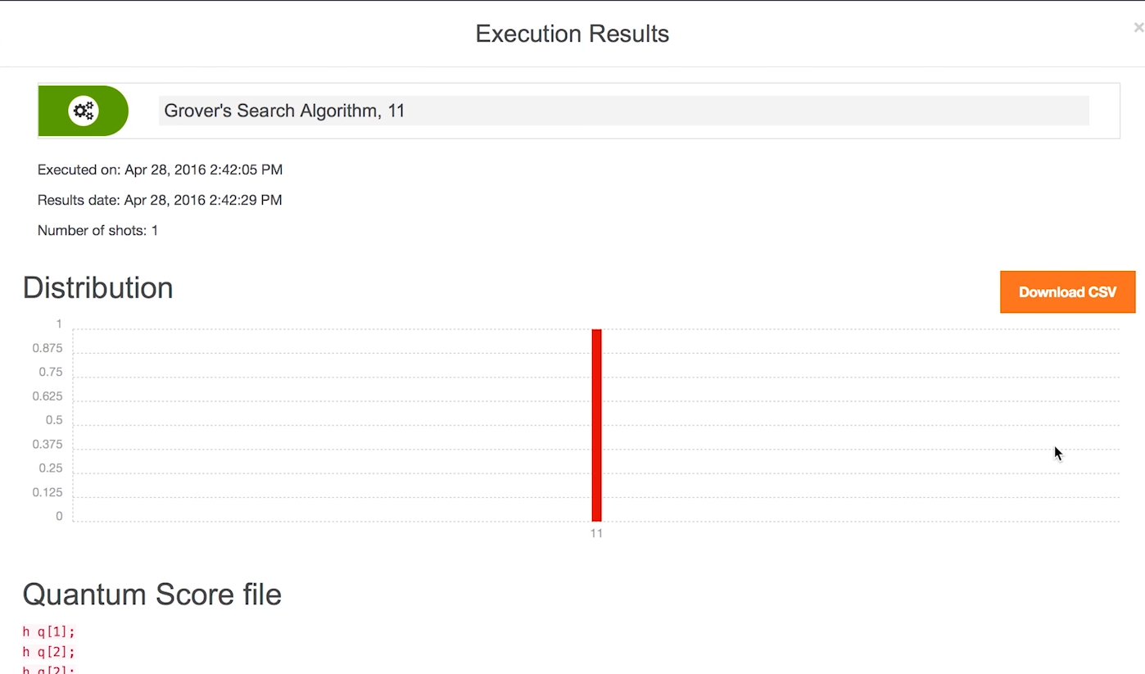

Here we found --- ‘11’

This corresponds to the fourth slots.

00 – slot 1

1. Slot 2

10- slot 3

11- slot 4

It means queen is on the fourth position.

Done..!!!!!